Sitting ducks
by COUNTRY NEWS

Feb 28,2020

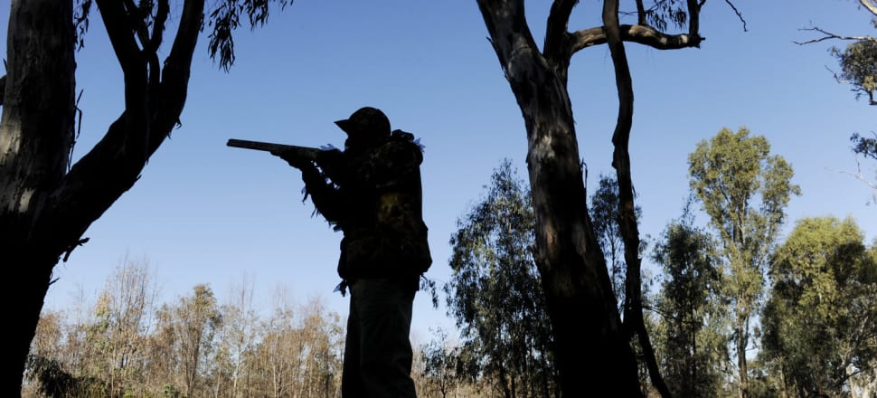
Many hunters are angered by the shortened duck hunting season.
The Victorian Game Management Authority has announced a shortened duck hunting season, including changes to the daily bag limit, leaving many avid hunters disappointed.
Duck season will start on Saturday, May 2, and run for five weeks, closing 30 minutes after sunset on Monday, June 8.
Field and Game Australia said it was outraged by the shortened season, calling it a "political compromise" and stating it would decrease regional tourism opportunities.
However, Field and Game Australia chairman Peter Hawker said members should make the most of the shortened season.
“With the community angst about the fires and the prominence of the climate change debate, it would have been easy and politically convenient for the government to abandon the season altogether,” Mr Hawker said.
Field and Game Australia’s view is that a more balanced approach to the 2020 Duck Season was possible; achieving sustainability while still affording hunters the opportunity to harvest reasonable numbers of game birds for the family table, and at the same time spending many millions of dollars in regional communities.
Shadow Agriculture Minister Peter Walsh said the shortened season was a clear sign of green ideology.
"Hunting injects more than $430 million into the state’s economy every year, providing a healthy boost for country communities — including those picking up the pieces after this summer’s catastrophic bushfires,” Mr Walsh said.
The restricted season was said to be a result of low duck numbers caused by prolonged dry conditions.
Hunters will be limited to three game ducks per day throughout the season, with the hunting of blue-winged shoveler prohibited for the entire season.
The start times on the opening weekend will be 8 am, with hunting times for the rest of the season running from 30 minutes before sunrise to 30 minutes after sunset.
The game duck species that can be hunted are Pacific black duck, mountain duck, chestnut teal, grey teal, pink-eared duck, wood duck and hardhead.
The group Regional Victorians Opposed to Duck Shooting has concerns duck hunting maps remain incomplete, failing to show the public waterways where duck shooting is allowed.
RVODS spokesperson Kerrie Allen said the Firearm Safety Code recommended a safety buffer of at least 250 m from family homes.
“Only 200-odd state game reserves and specified hunting areas are shown on the GMA website, however, duck shooting is allowed on an estimated 8000 to 15 000 lakes, creeks, streams, reservoirs, wetlands around the state, often in close proximity to the public,” Ms Allen said.

